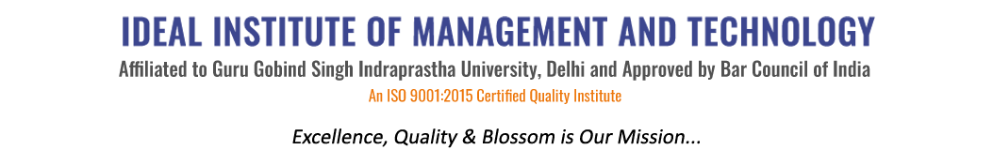
16 X, Karkardooma Institutional Area, (Near Telephone Exchange)
Delhi-110092
+91 (11) 22372639, 22375961,
http://idealinstitute.edu.in

Dated: 16th October, 2013
NOTICE
Guidance for Competitive Examination and Career Counseling

All the students of BBA, BBA (CAM), B.A. LL.B. (H), BBA 2ND Shift, BBA (CAM) 2nd Shift of final year are hereby informed that the Institute is organizing Guidance for Competitive Examination and Career Counseling regarding the Mock Interview Sessions on 30th October, 2013, Wednesday from 2.30 p.m in the Auditorium. It is Mandatory for all the students of final year of aforesaid courses to attend the same. This programme is facilitated by Mr. Avinash from Mylaw.net.
Anil Parkash Sharma
(Director)

16 X, Karkardooma Institutional Area, (Near Telephone Exchange)
Delhi-110092
+91 (11) 22372639, 22375961,
http://idealinstitute.edu.in

Dated: 21st October 2014
NOTICE
Guidance for Competitive Examination and Career Counseling

All the students of BBA, BBA (CAM), B.A. LL.B. (H), BBA 2ND Shift, BBA (CAM) 2nd Shift of final year are hereby informed that the Institute is organizing Guidance for Competitive Examination and Career Counseling regarding the Campus Placement Drive on 5th November, 2014, Wednesday from 1:45 p.m in the Auditorium. It is Mandatory for all the students of final year of aforesaid courses to attend the same.

Prof.(Dr.) Anil Parkash Sharma
(Director)

16 X, Karkardooma Institutional Area, (Near Telephone Exchange)
Delhi-110092
+91 (11) 22372639, 22375961,
http://idealinstitute.edu.in

Dated: 1st October 2015
NOTICE
Guidance for Competitive Examination and Career Counseling

All the students of BBA, BBA (CAM), B.A. LL.B. (H), BBA 2ND Shift, BBA (CAM) 2nd Shift of final year are hereby informed that the Institute is organizing Guidance for Competitive Examination and Career Counseling regarding the 2 days orientation session on CAT/CLAT on 15th October 2015, Thursday from 2.45 p.m in the Auditorium. It is Mandatory for all the students of final year of aforesaid courses to attend the same. This programme is facilitated by Dr. Anil Parkash Sharma.

Prof.(Dr.) Anil Parkash Sharma
(Director)

16 X, Karkardooma Institutional Area, (Near Telephone Exchange)
Delhi-110092
+91 (11) 22372639, 22375961,
http://idealinstitute.edu.in

Dated: 20th September, 2016
NOTICE
Guidance for Competitive Examination and Career Counseling

All the students of BBA, BBA (CAM), B.A. LL.B. (H), BBA 2ND Shift, BBA (CAM) 2nd Shift of final year are hereby informed that the Institute is organizing Guidance for Competitive Examination and Career Counseling regarding the IT (Networking) Workshop on 4th October 2016, Tuesday from 3 p.m in the Auditorium. It is Mandatory for all the students of final year of aforesaid courses to attend the same.

Prof. (Dr.) Anil Parkash Sharma
(Director)

16 X, Karkardooma Institutional Area, (Near Telephone Exchange)
Delhi-110092
+91 (11) 22372639, 22375961,
http://idealinstitute.edu.in
Dated: 3rd October 2017
NOTICE
Guidance for Competitive Examination and Career Counseling

All the students of BBA, BBA (CAM), B.A. LL.B. (H), BBA 2ND Shift, BBA (CAM) 2nd Shift of final year are hereby informed that the Institute is organizing Guidance for Competitive Examination and Career Counseling regarding the Workshop on Enhancing Communication Skills on 10th October 2017, Tuesday from 2.30 p.m in the Auditorium. It is Mandatory for all the students of final year of aforesaid courses to attend the same. This programme is facilitated by Prof. (Dr.) T.P.S. Rathore.
Prof.(Dr.) Anil Parkash Sharma
(Director)

